Caitlin Schlagal

29 December 2020

Guided Capstone – Summary

The initial question posed was, how can Big Mountain update their pricing strategy and increase ticket price, based on offered facilities, for the upcoming season? Big Mountain is a ski resort that caters to skiers and riders of all levels and has access to 105 trails. Recently they installed a new lift to accommodate more visitors. Management was looking to review their current pricing strategy to find the most efficient approach to increase value of ticket price, while focusing on leveraging specific facilities within the resort. As such our primary aim was predicting adult weekend ticket price, and all states were treated equally as there were no patterns or differences between them.

Our best model, and the one we used for our analysis, was a random forest regression. Performance with this model was consistent in the training and test set and output was consistent with a linear model. We decided on the random forest model due to a lower cross-validation mean and this model demonstrated less variability overall. We then used this model to calculate the ticket price for Big Mountain and our model predicted a ticket price of $95.87, while the current price is at $81.00. With the expected mean absolute error at $10.39, there is still the option to increase ticket price.

We investigated the facilities that were most dominant as predicted by our model. These included; fastQuads, vertical drop, snow making area, the total number of runs and skiable terrain. This is important because these facilities could then have the greatest impact on determining ticket price and can serve as a predictor for future business decisions, such as, which areas should the resort invest in over others.

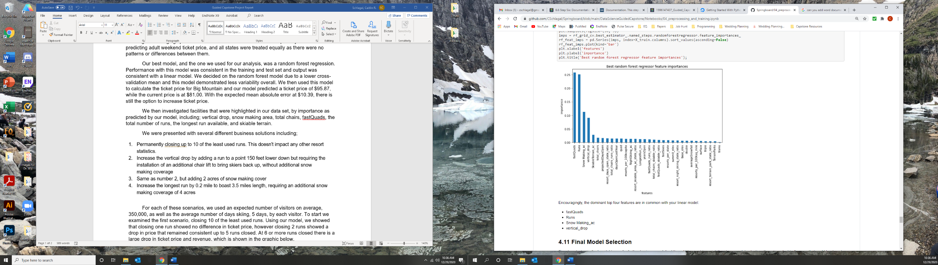

We were presented with several different business solutions including;

1. Permanently closing up to 10 of the least used runs. This doesn't impact any other resort statistics.
2. Increase the vertical drop by adding a run to a point 150 feet lower down but requiring the installation of an additional chair lift to bring skiers back up, without additional snow making coverage
3. Same as number 2, but adding 2 acres of snow making cover
4. Increase the longest run by 0.2 mile to boast 3.5 miles length, requiring an additional snow making coverage of 4 acres

For each of these scenarios, we used an expected number of visitors on average, 350,000, as well as the average number of days skiing, 5 days, by each visitor. To start we examined the first scenario, closing 10 of the least used runs. Using our model, we showed that closing one run showed no difference in ticket price, however closing 2 runs showed a drop in price that remained consistent up to 5 runs closed. At 6 or more runs closed there is a large drop in ticket price and revenue, which is shown in the graphic below.

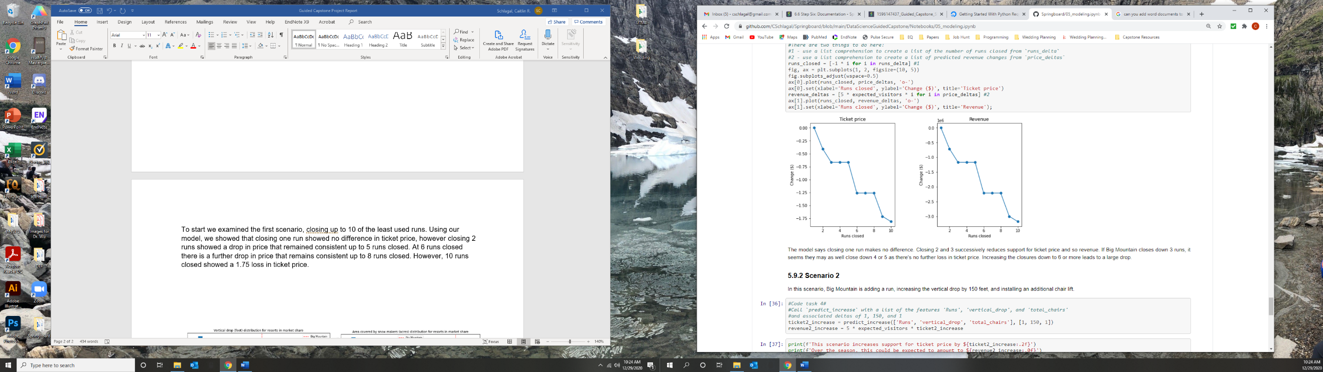

We then examined the second scenario, in which Big Mountain would add a run, increase the vertical drop by 150 feet and install an additional chair lift. Using our model, we showed that this scenario supported a ticket price increase of $1.99, as well as, a predicted season income to be around $3,500,000. The third scenario, which is similar to the second but included an extra 2 acres of snow making, showed no difference in ticket price or the expected amount to be made over the season. The fourth scenario, which called for increasing the longest run by 0.2 miles and adding 4 acres of snow making, showed no impact on ticket price. This could be due to our model predicting longest run, as less important than other facilities offered by the resort.